“Intelligence without ambition is a bird without wings.”

MY LIFE IN PHNOM PENH

**MENGKORNG LY**

Table of Contents

MY FIRST WEEk AT PNC 2

1 3

I WERE A FRUIT AND THE DAY I WANT TO BE A FRUIT 3

2 4

MY HOME TOWN 4

ADVANTAGES 4

DISADVANTAGES 4

3 5

WHERE I WANT TO SEE MYSELF IN 5 YEARS 5

# MY FIRST WEEk AT PNC

WHEN I COME TO **PNC[1].** I HAVE A NEW EXPERIENCE THAT I DON’T HAVE BEFORE. I LIVE WITHOUT MY FAMILY, WITHOUT MY HIGH SCHOOL FRIENDS, AND LIVE IN NEW SITUATION THAT I DIDN’T EXPECT BEFORE. FIRST WEEK AT **PNC** I FEEL LONELY AND SOMETIMES I CRIED WHEN I THINK ABOUT MY FAMILY. HOWEVER, I FEEL HAPPY AND HAVE COMFORTABLE WHEN I HAVE TRIP WITH MY NEW FRIENDS AND TEACHERS IN **PNC.** WE PLAYED GAMES TOGETHER AT TAMAO MOUNTANT AND MAKE COMMUNICATION BETTER THAN.

# **1**

# I WERE A FRUIT AND THE DAY I WANT TO BE A FRUIT

If I WERE A FRUIT I WANT TO BE A BANANA. BECAUSE BANANA IS A KIND OF FRUIT THAT I LIKE SINCE I WAS a YOUNG. IT IS SWEET AND DELICIOUS. I always eat banana when i have it.

If possible, i want to be a banana and say “come on eat me, my girl.” And the day that i want become a banana is the day when i want.

# **2**

# MY HOME TOWN

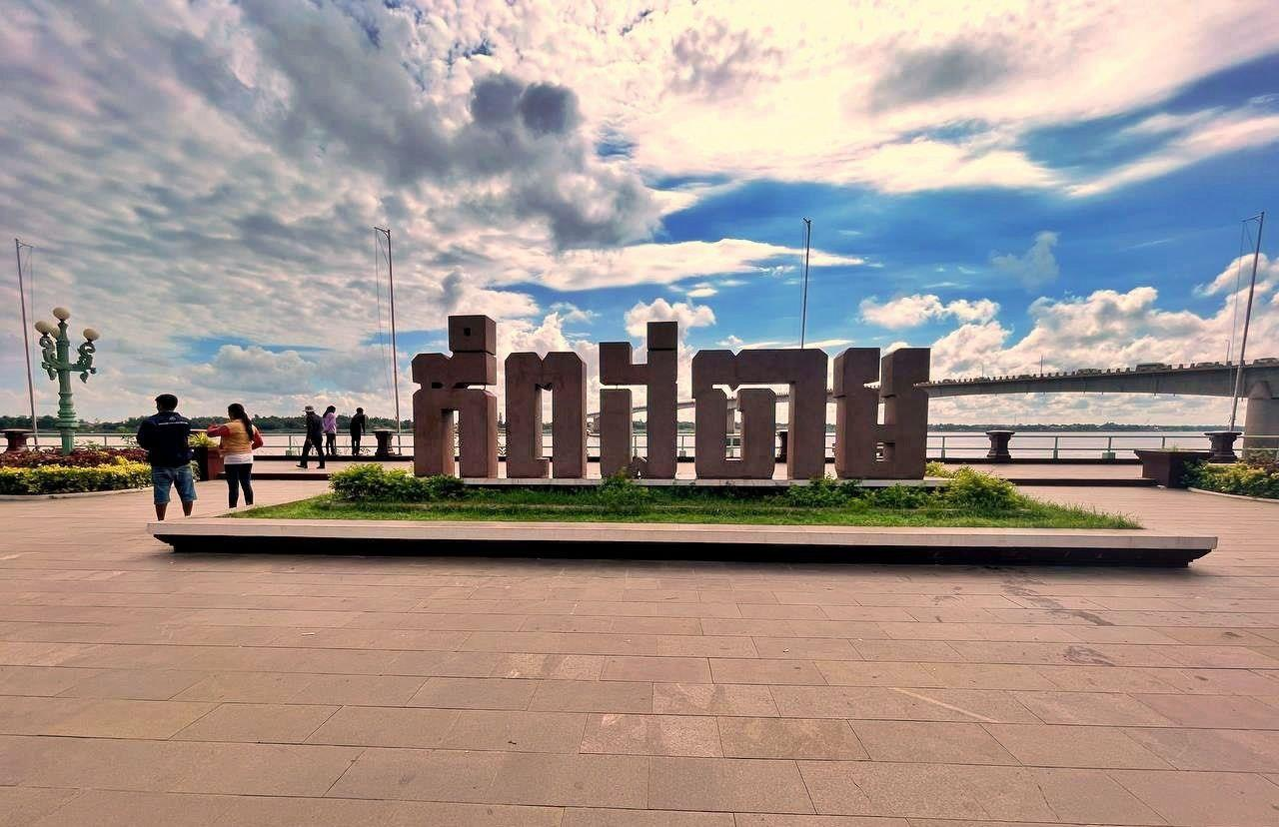

**Kampong Cham**[2]is a Province of Cambodia located on the central lowlands of the Mekong River. It borders the Province of Kampong Chhnang to the west, Kampong Thom and Kratie to the north, Tboung Khmum to the east, and Prey Veng and Kandal to the south.

Figure :Kampong cham Logo

## ADVANTAGES

**Kampong Cham** has long been known as the agricultural centre of Cambodia. Over the years, agri-business has driven our local economy and enabled us to prosper economically and socially.

## DISADVANTAGES

**Kampong Cham** has This relatively small city has yet to be heavily touristed like Phnom Penh or Siem Reap. Most travellers who do find themselves in Kampong Cham are in transit to elsewhere in the country, but those that choose to spend at least a couple of days in the provincial capital.

# **3**

# WHERE I WANT TO SEE MYSELF IN 5 YEARS

IN 5 YEARS, I WANT TO SEE MYSELF IN A PLACE THAT HAVE EVERYTHING THAT I WANT. I HAVE A GOOD JOB, GOOD SALORY. AND SUPPORT MY FAMILY AS MUCH AS POSSIBLE. ESPECIALLY HAVE A GOOD PARTNER WHO CAN :

* LIVE TOGETHER
* HELP EACH OTHER
* LOVE MY FAMILY MORE THAN ME
* PROVIDE COMFORTABLE
* I CAN TRUST

Table of Contents

MY FIRST WEEk AT PNC 2

1 I WERE A FRUIT AND THE DAY I WANT TO BE A FRUIT 3

2 MY HOME TOWN 4

ADVANTAGES 4

DISADVANTAGES 4

3 WHERE I WANT TO SEE MYSELF IN 5 YEARS 5

1. Passerelles numeriques Cambodia
2. Is a province of Cambodia